04_Wazuh_Architecture

1. What is Wazuh?
Wazuh is an open-source security monitoring platform used for threat detection, security analysis, vulnerability detection and endpoint monitoring.
It helps organizations monitor Windows and Linux systems and detect suspicious activities.

2. Wazuh Architecture
Wazuh has four main components.
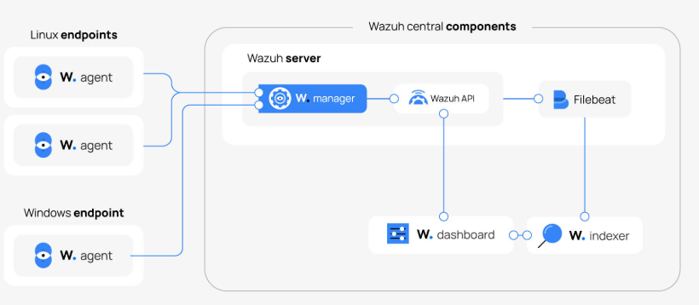
1. Wazuh Agent
- Installed on Windows or Linux endpoints.
- Collects system and security logs.
- Monitors file changes.
- Sends collected security information to Wazuh Manager.
2. Wazuh Manager
- Receives events from agents.
- Analyzes and processes security events.
- Uses decoders and rules to identify threats.
- Generates security alerts.

3. Wazuh Indexer
- Stores and indexes security alert data.
- Makes searching and analyzing events faster.
- Supports security data queries.
4. Wazuh Dashboard
- Provides a graphical interface.
- Displays security alerts and events.
- Helps analysts monitor agents and investigate incidents.

3. Wazuh Data Flow
- Agent collects endpoint logs.
- Agent sends events to the Manager.
- Manager processes events using decoders and rules.
- Alerts are sent to the Indexer.
- Dashboard displays the alerts.

4. What are Decoders?
A decoder is a component that extracts useful information from raw log messages.
It converts unstructured log data into structured fields.
Example: Raw log
Failed password for admin from 192.168.1.10

Extracted fields:
Field | Value
Event | Failed password
Username | admin
Source IP | 192.168.1.10

5. What are Wazuh Rules?
Rules analyze decoded events and determine whether an event should generate an alert.
Example:
- Multiple failed SSH login attempts.
- Unauthorized file modifications.
- Suspicious system activities.
Wazuh Rule Levels (0–15)
Level | Meaning
0 | Ignored events
1 | None/very low priority
2 | System notification
3 | Successful system events
4 | Authentication failures
5 | User-generated errors
6 | Low-priority attacks
7 | Bad word matching
8 | First-time occurrence
9 | Error from invalid source
10 | Multiple errors
11 | Integrity checking warning
12 | High-importance event
13 | Unusual error or attack
14 | High-severity security event
15 | Severe security alert

Note: Rule levels indicate alert severity, not a guaranteed measure of attack success. Actual rules determine the assigned level.

6. Advantages of Wazuh
- Open-source security platform.
- Endpoint monitoring.
- File Integrity Monitoring (FIM).
- Vulnerability detection.
- Security alert generation.
- Supports Windows and Linux.

Example
If an unauthorized user modifies an important system file, Wazuh can detect the file change and generate a security alert.
Conclusion: Wazuh provides centralized security monitoring and helps SOC analysts detect suspicious endpoint activities.

